How to create a Scatter Plot in Excel

1. Highlight the data you wish to put into your graph.

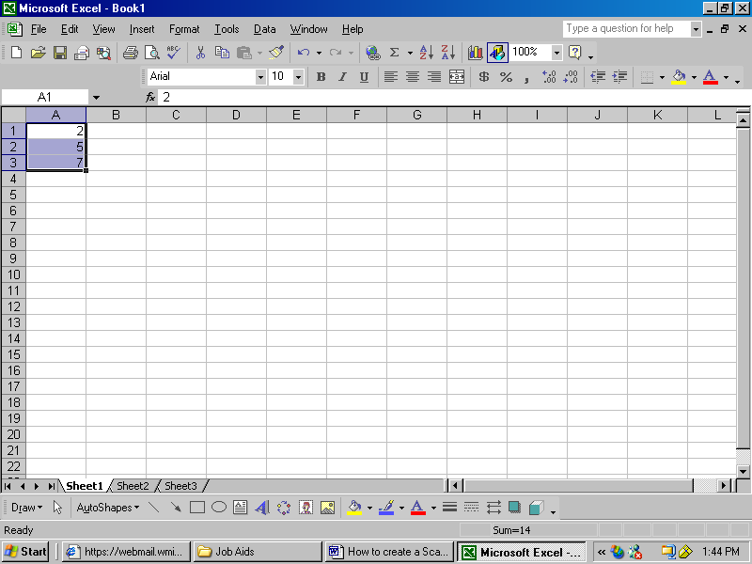

2. Select the “Chart Wizard” from the tool bar

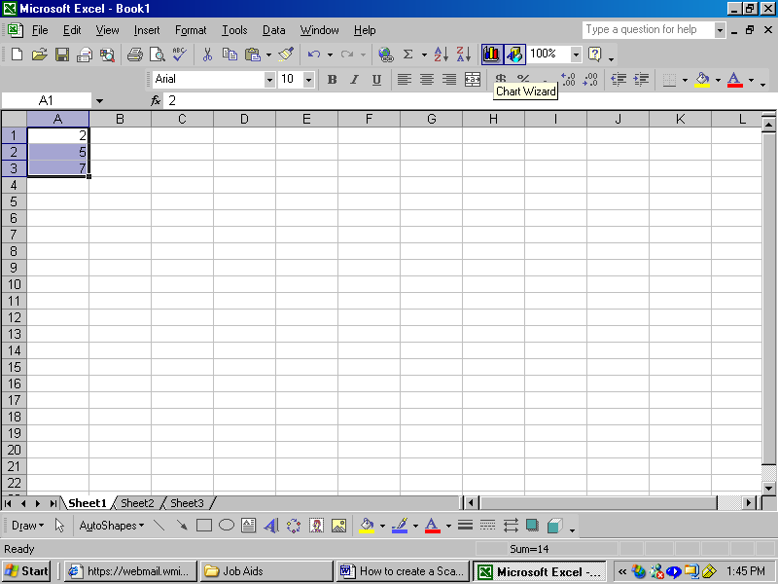

3. Select “XY (Scatter)” for the chart type

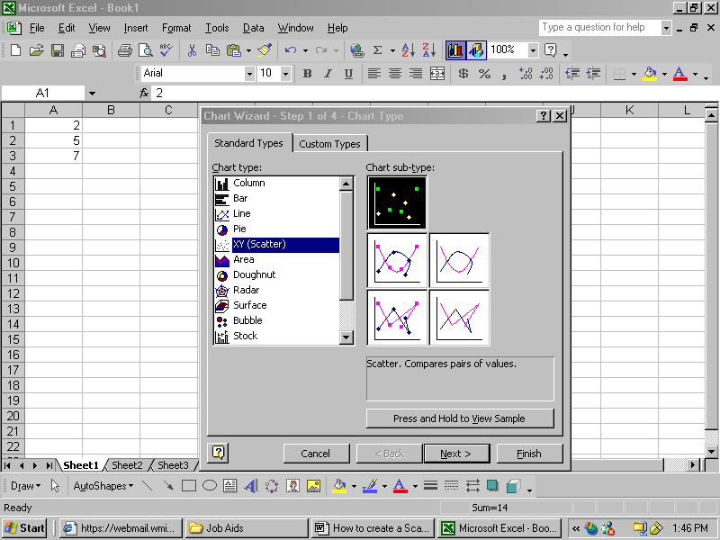

4. Click next and then choose “Rows or Columns”

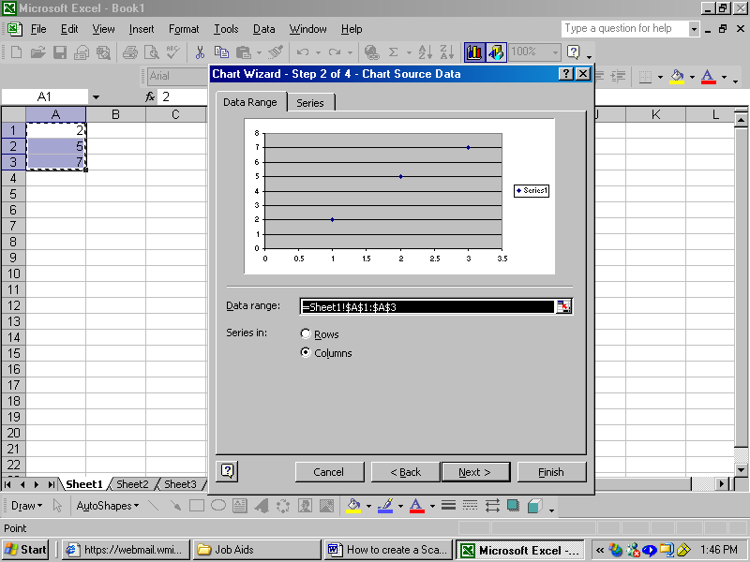

5. Click next again and on that screen you can fill in the Chart Title and the X and Y values.
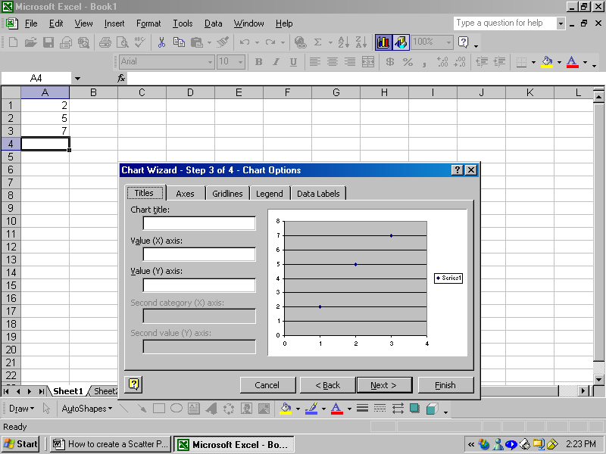

6. Click on the gridlines tab to remove or insert the gridlines to your liking. Click to put a checkmark next to the gridlines you want to be shown, click to remove the checkmarks next to the gridlines you do not want to be shown.

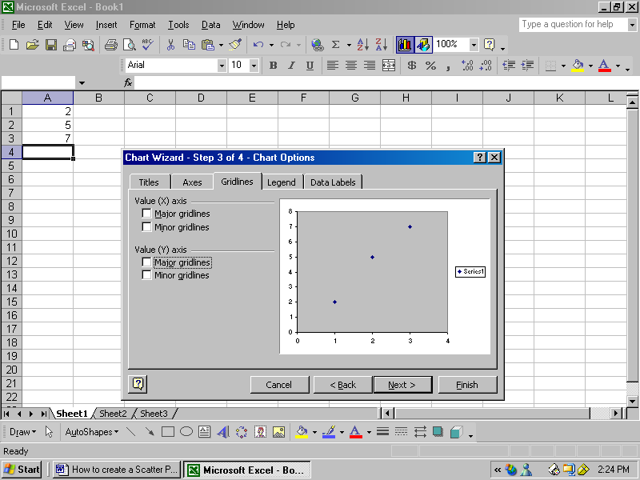

7. Click Next and then click Finish
8. When your graph is made there are a number of different things you can do such as make the data points different colors, the backgrounds different colors, and remove the key.

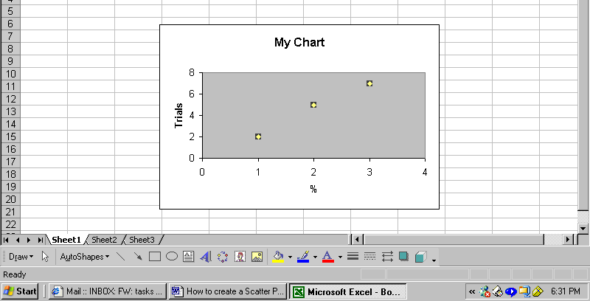

9. To change the color of the data point right mouse click on them, to change the background right mouse click on the background.

10. Then scroll down and click on Format Data Series
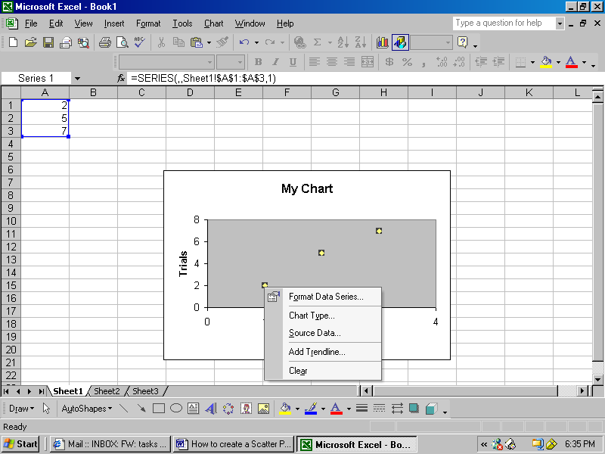

11. Here you can change the color of the background, data points, the foreground of the data points, and the style of the data point.

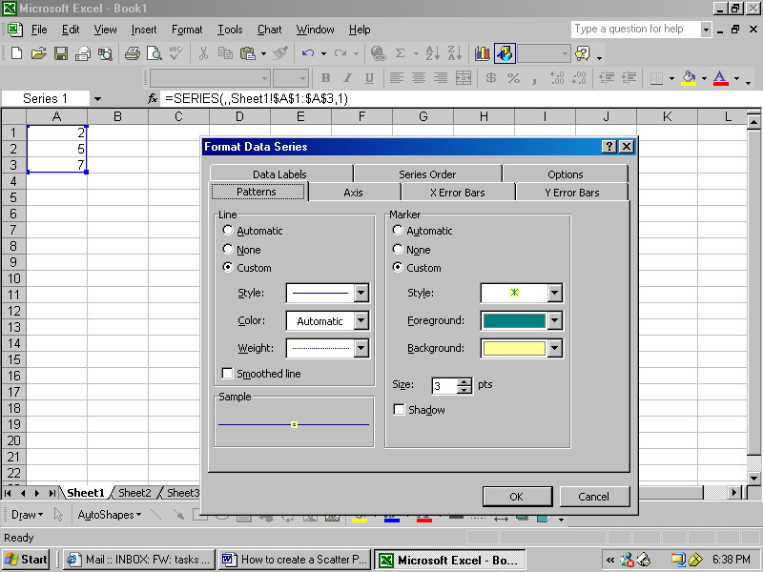

12. If you would like your scatter plot graph to be a line graph, fill in the Automatic circle under line.
13. To create a bar graph follow the same steps as with the scatter plot, but when it asks which type of graph you would like chose the column graph.
