Multiple Baseline Design Graph

Step 1: Once you have made a graph, double click on the gray shaded area within your graph.

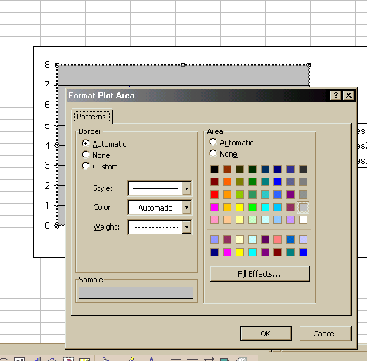

Step 2: Change the border selection to NONE, and the area section to NONE. Then click OK. This has removed the gray background and the right border from the graph

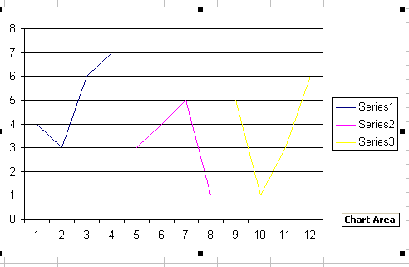

Step 3: Click on the text box icon on the drawing tool bar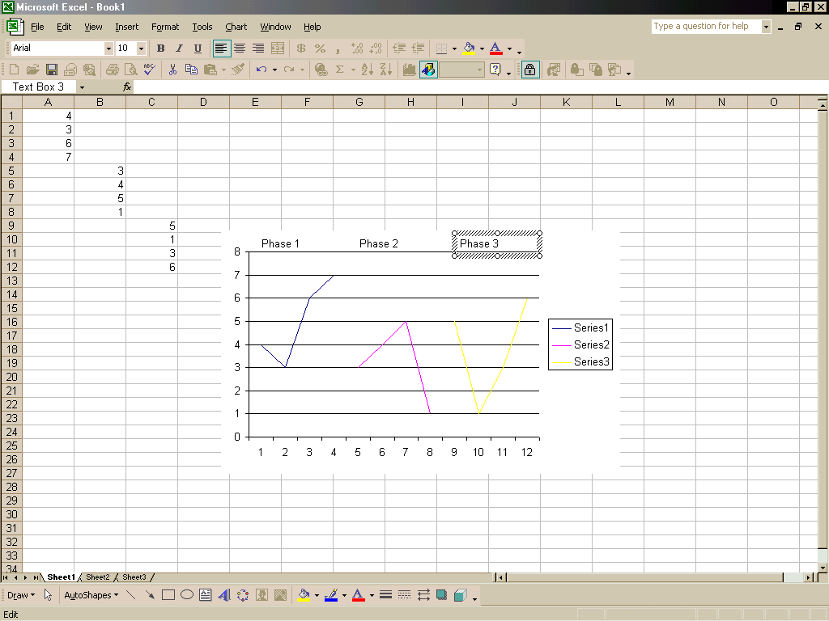, and use the drag and drop technique to create an area over your phase and type in the phase label, repeat until all phases are labeled. (After you click on the text box icon, click on the excel sheet again. The text box will appear. Type in your desired text and adjust the size of the text box accordingly. Then drag the text box to where you want it to appear in the graph).

Step 4: Click on the line button 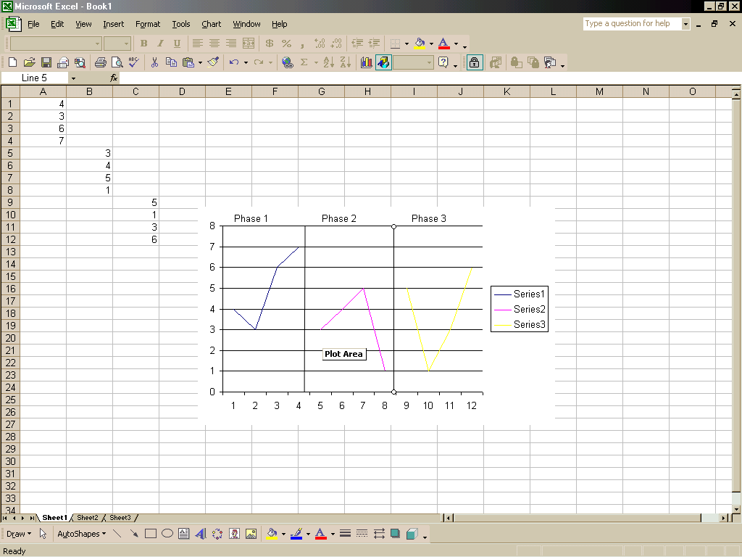to create lines between phases. Place the pointer over the place you want to begin your line. Click and drag your mouse pointer until you have created your vertical line.

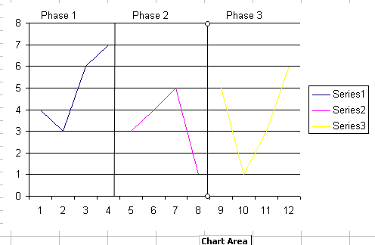

Step 5: Double click on your vertical line to bring up your format AutoShape box. Click on the dashed box to pick your dashed line. Click OK.
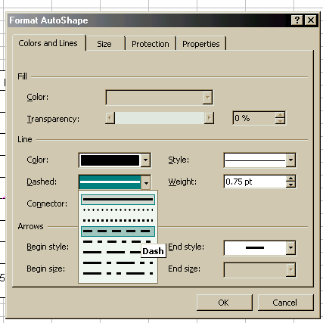

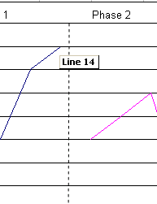
You must place your cursor directly on the line when you double click or you will choose the plot area instead of the line.

Step 6: Double click on the Y-axis

Step 7: This will bring up your format gridlines box where you want to set your minimum and “X axis crosses at” to negative 1. Then press OK, this will display your graph at -1 on the abscissa and the zero will be raised.

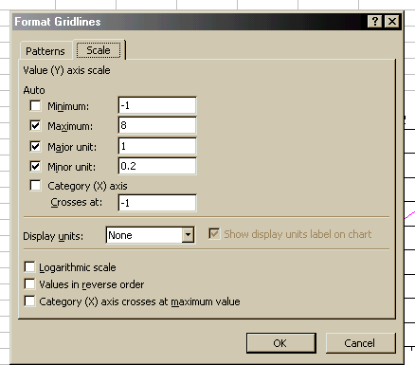

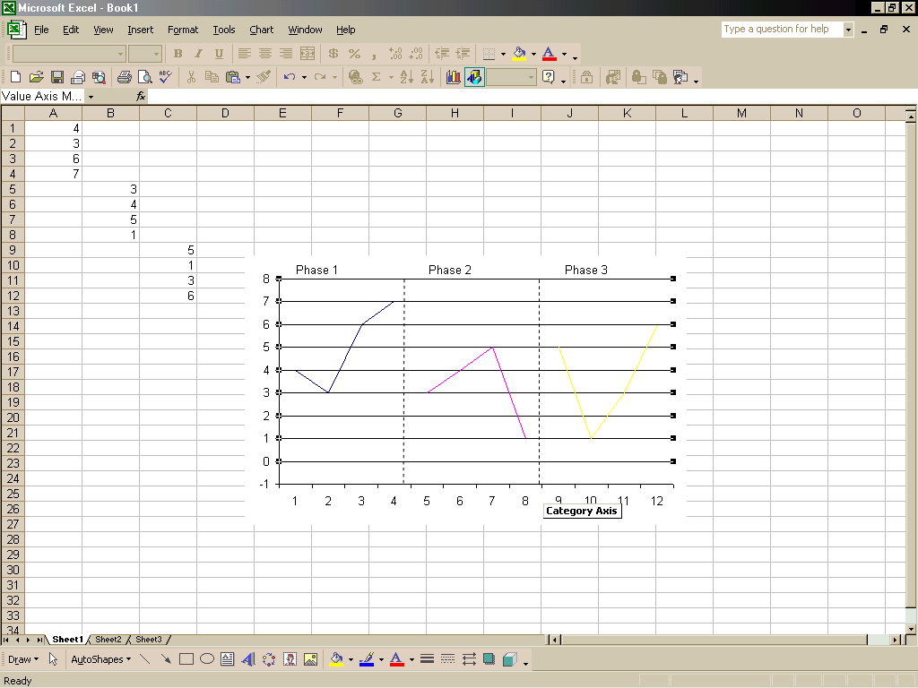

Step 8: Select the text box icon, make an icon box and double click the box. Under the colors and lines tab, choose white as your fill color. Once completed, move the icon box over the -1 to hide it. Now your Y-axis will start from zero.

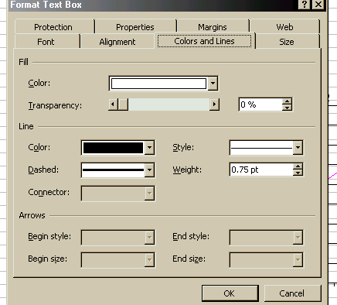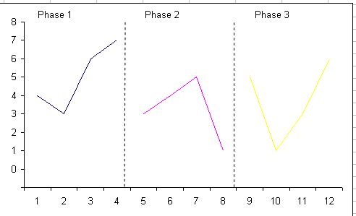

Step 9: Click only once on your graph then head back to the graph wizard button. 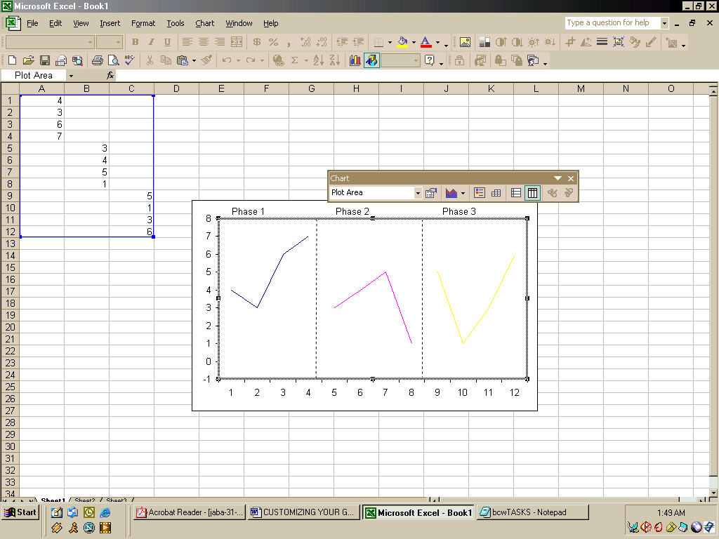

Step 10: Just click next for the first two phases. Once on the third phase, click on the gridlines tab and uncheck Y major gridlines following that task, move to the legend tab and uncheck show legend.

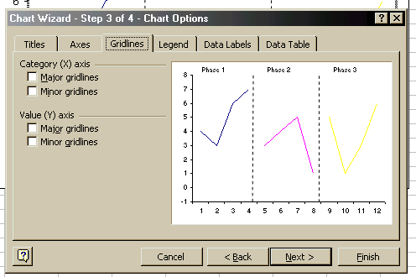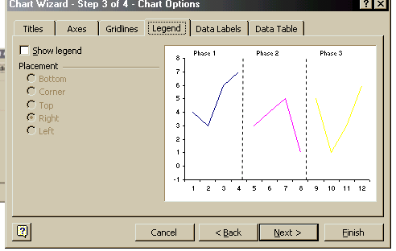

Step 11: The last and final step is to name your X and Y axis. This is done by clicking the Titles tab and filling in your desired category names. Click next and then finish.

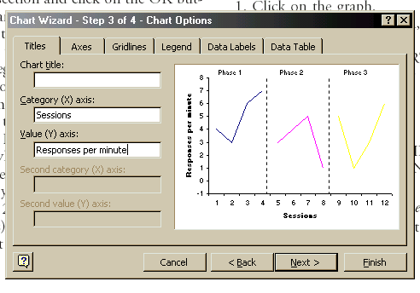

Step 12: Repeat steps 1-10 for your next graph then vertically align both graphs with your new graph on top.

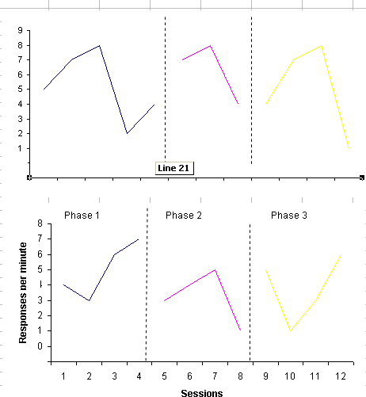
Step 13: Once you have your two graphs, click the X axis of your top graph. Under the patterns tab, choose NONE for tick mark labels. Then choose OK
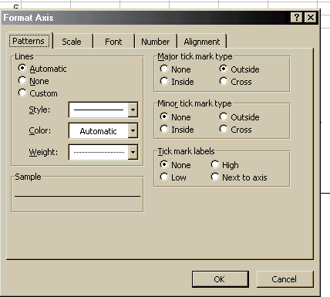

Step 14: We need to head back to our first graph and erase our Y axis label because in a multi baseline design graph, both graphs share the same labels.

Step 15: Click on the text box and insert your Y axis label and place it in the middle of both graphs. Double click the edge of the text box and choose the vertical orientation option located under the alignment tab.

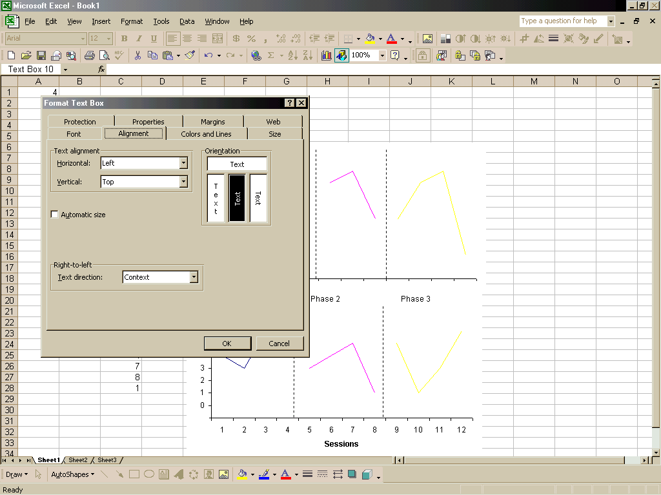

Step 16: Click OK and you should have both graphs properly labeled

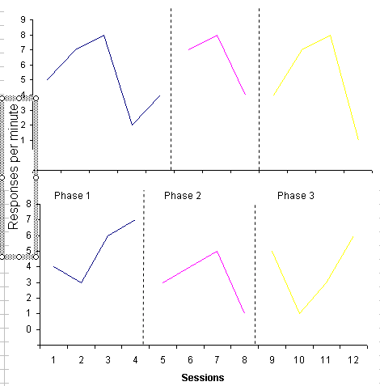

Step 17: Choose the line button in your toolbar and make a new line that connects your baselines. Properly format to a dashed line and then you have a complete multi baseline design graph.



