To accept an appointment:
1. When the appointment is sent to you in Outlook, it will appear just like any other email message. Open the appointment.
2. At the top left-hand side of the screen, click Accept. The appointment will then be sent as “accepted” to the sender and be entered into your calendar. Or, you can tentatively schedule it, decline it, or propose a new time.
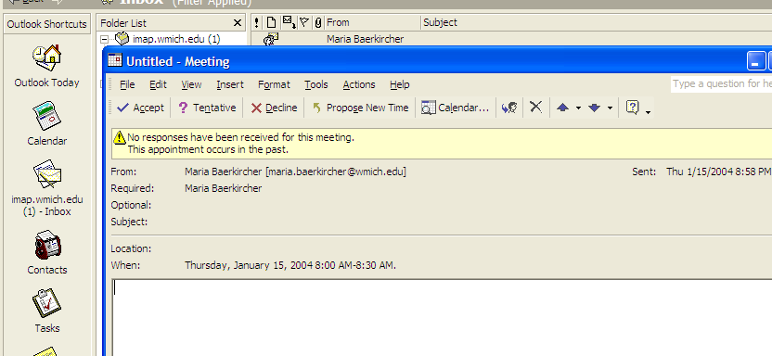

Another way of accepting tasks and appointments:
1. Simply click on the email, and drag it into either your task folder or your calendar folder.
