Track Changes

1. Open a word document.
2. To begin using track changes, you can either:
-Click the track changes icon on the tool bar
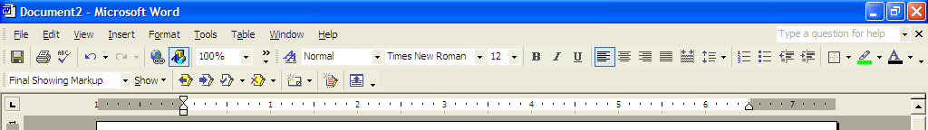

-Click on tools on the menu bar, scroll down and click on track changes
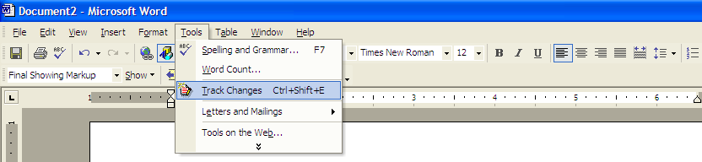

-Press Ctrl+Shift+E

3. Now, any changes made to the word document will be documented.
4. For example, if you delete a word, it will show up in the right hand of the column. It will say what word or what letters were deleted, and where at in the document the words or letters were deleted from.

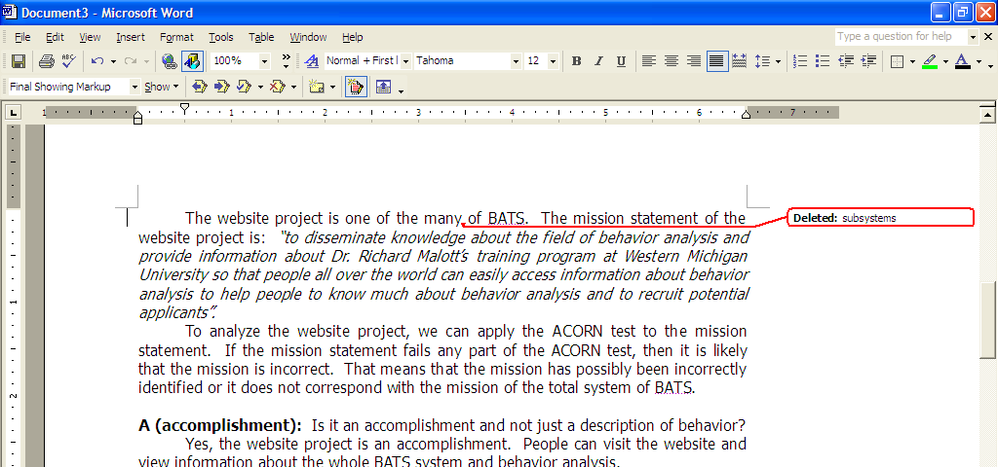

5. If you add a word, it will show up underlined and in color.
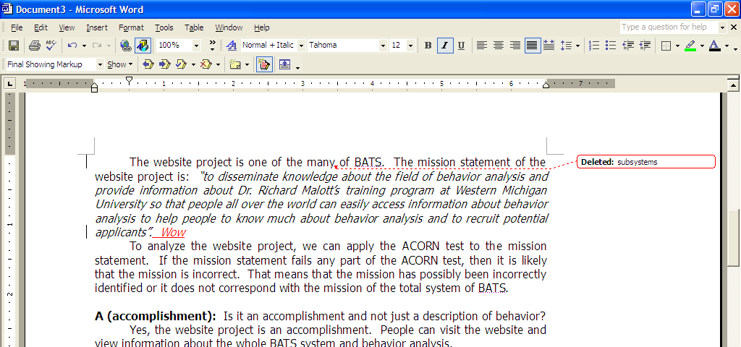

6. If you would like to add a comment, click in the document where you would like to add a comment. Then, click on the comment icon on the menu bar.

7. The comment will then be inserted, then just click in the comment box that appears and write your comment. If you would like to make a comment about an entire paragraph, for example, highlight the text that you would like to make a comment about, then click on the comment icon on the menu bar. Brackets will appear around the selected text.
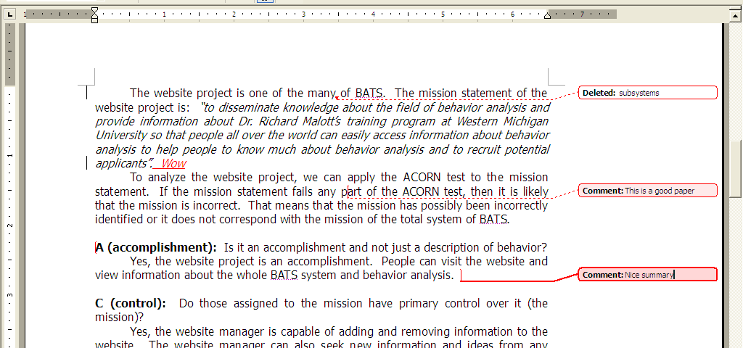

8. When reviewing a document with track changes, you can use the arrows on the menu bar to scroll back and forth to each track change.
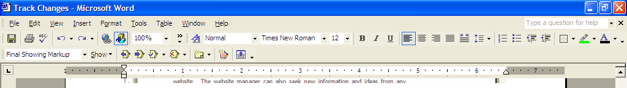

9. Then, when you are doing revisions on your document, you can accept or delete the track changes one of two ways. The first way is to right click on the title of the track change. So right click where it says ‘deleted.’ You can then scroll down to and click ‘accept deletion’ or ‘reject deletion.’
Or, you can go to the menu bar and click ‘accept change.’ Likewise, you can go to the menu bar and click ‘accept deletion.’ To accept all of the deletions or to reject all of the changes, go to the menu bar, click on the arrow next to either the ‘accept change’ button or the ‘reject change’ button, scroll down and click on ‘accept all.’

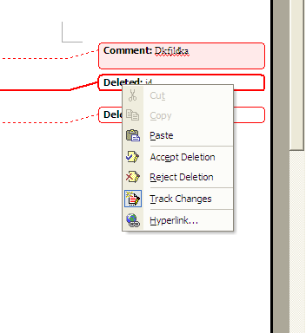
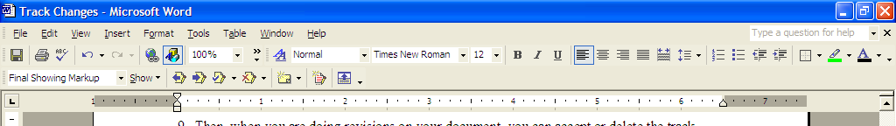

10. For comments, you can do the same thing. You can right click on the comment where it says ‘comment,’ and then scroll down to delete comment. Or, you can go to the menu bar and click on the arrow next to ‘reject change/delete comment,’ and scroll down and click on ‘reject change/delete comment.’
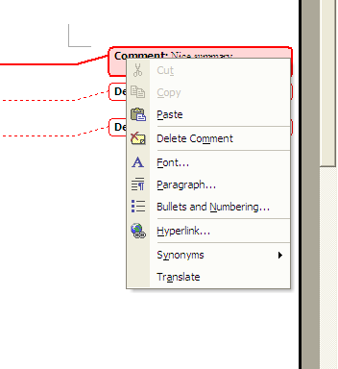
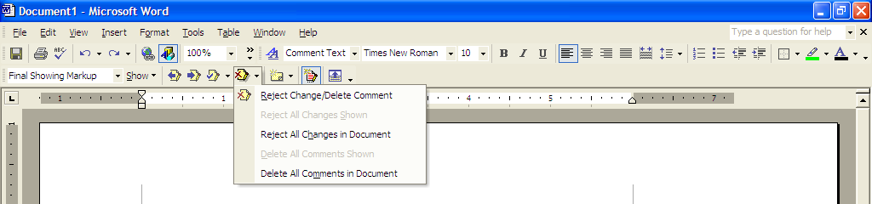

- To accept the additions to the text, click on the added text, then go to the menu bar, click on ‘accept change,’ and then scroll down to either ‘accept change’ or ‘accept all changes in document.’

