Microsoft Outlook: Notes in Outlook

- Open Microsoft Outlook

- Click on the scroll down arrow next to the “New” button

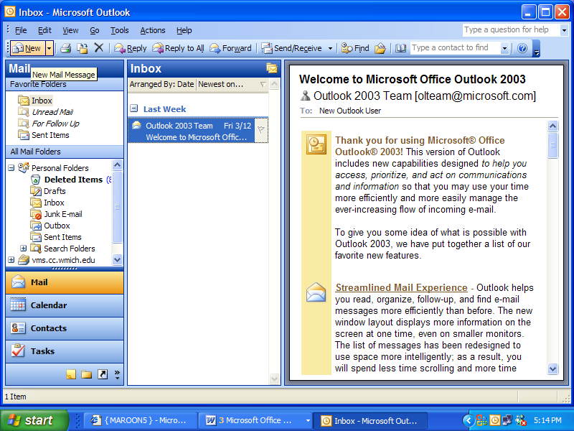

- Click on “Note”

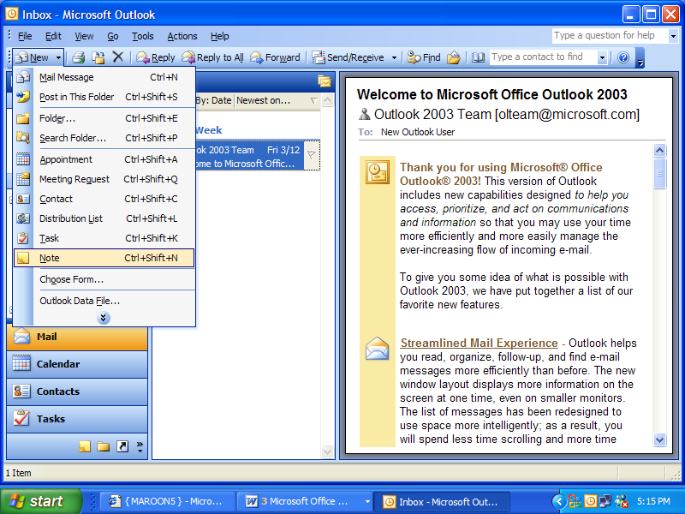

- When the note page appears it may be very small, click on the corner of the window and drag to a size of your liking.

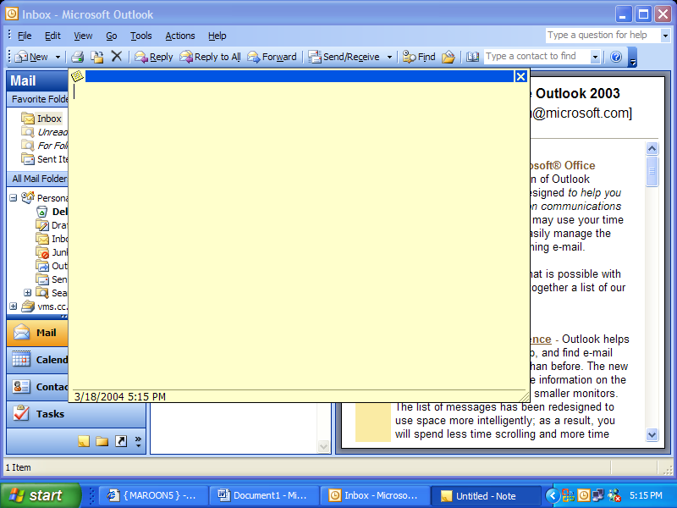

- Then click on the notes icon in the upper left corner of the screen and select “Save as”

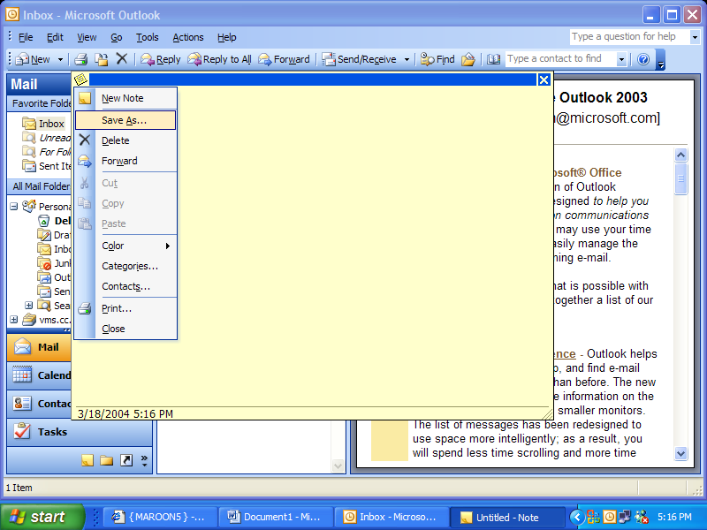

- Select an appropriate folder and save your note

Signatures

- Click on “Tools” then scroll down to “Options”

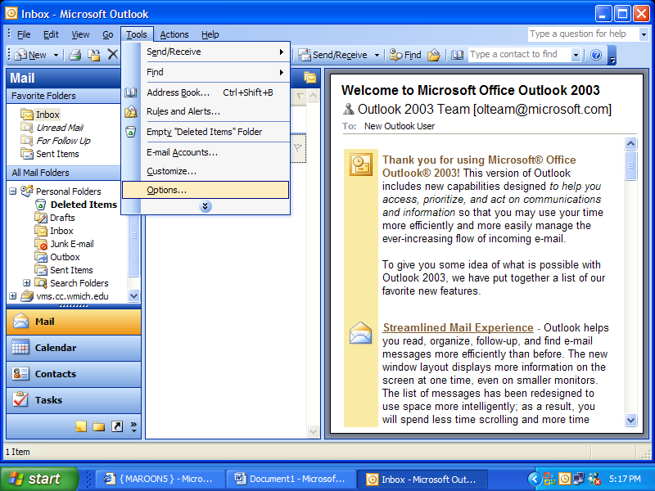

- Click on the “Mail Format” tab

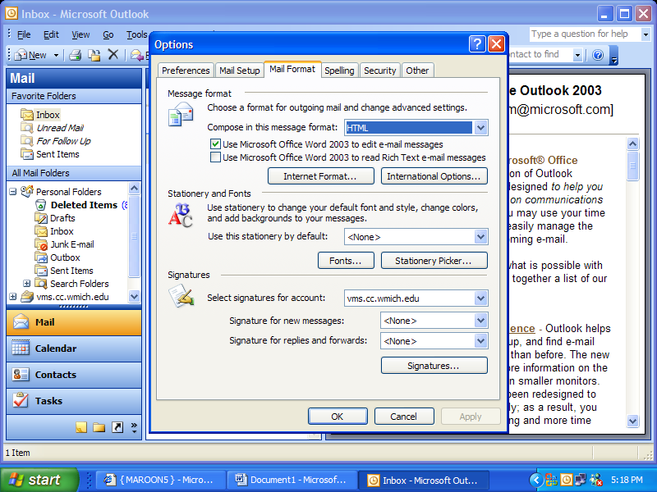

- Click on the “Signatures…” Button

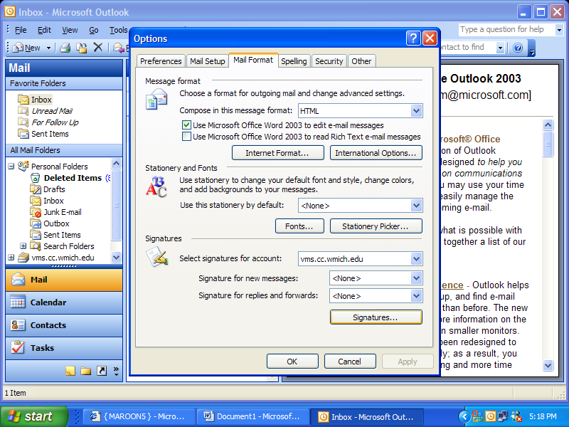

- Click on “New”

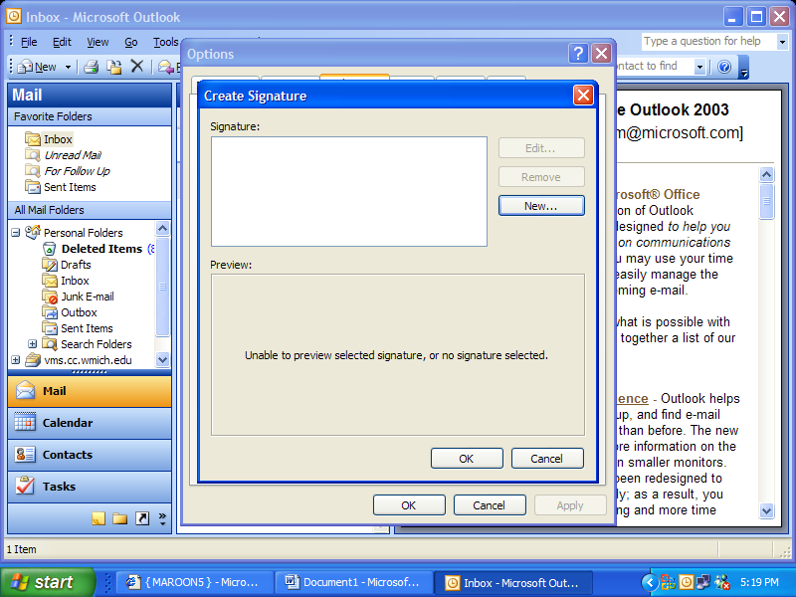

- In the “Enter a name for your new signature” field create a name for your signature. (ex. Professional, Friends)

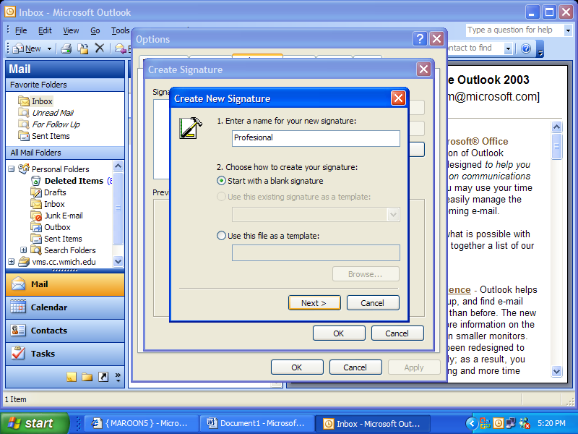

- Then check wee it says “Start with blank signature” and click “Next”

- Here you can create a signature and using the “Font, Clear, Paragraph, and Advanced” buttons you can create your signature.

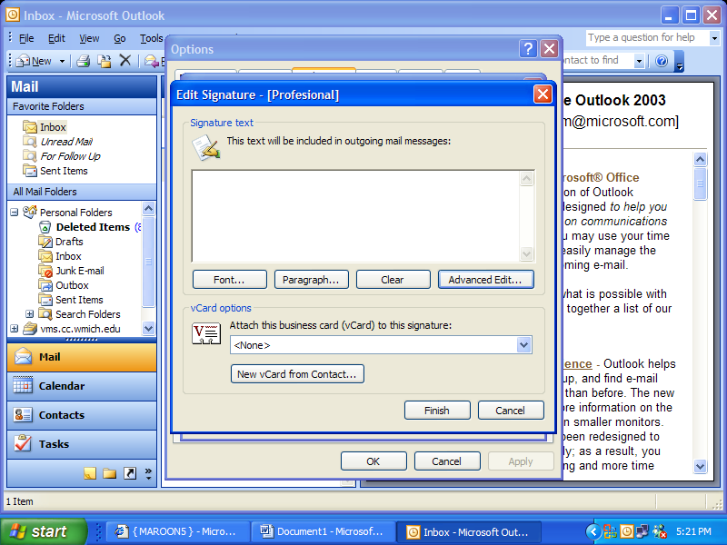
- Click “Finished” when done then “OK”
Replying and Replying to all

- When you receive an Email in out look you can do one of two things. You can reply to the email using the “Reply” feature or you can use the “Reply to all” feature.
- To just reply to the person who sent you the email just click on the “Reply” button on the tool bar.
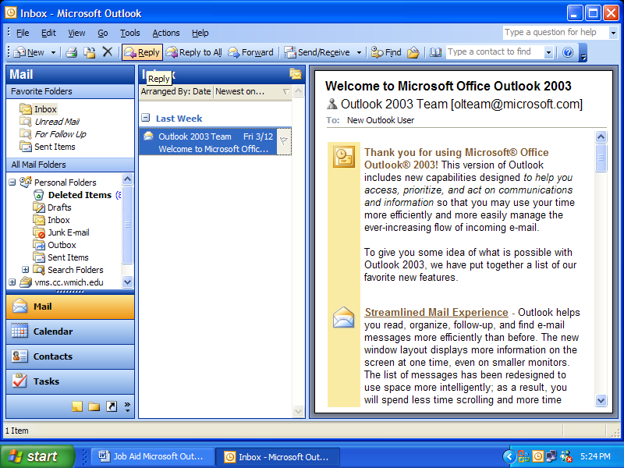
- Then write your email and send it.

- If you would like to reply to the person who sent you the email and everyone else who they emailed click on the reply to all button.
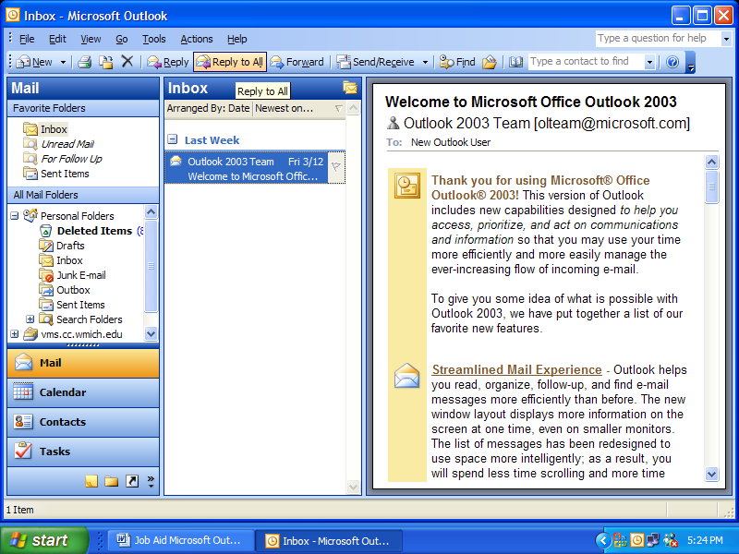
- Then write your email and send it.

