Chapter 8
How to Deal with Dope

He shall separate himself from wine and strong drink, and shall drink no vinegar of wine, or vinegar of strong drink, neither shall he drink any liquor of grapes, nor eat moist grapes, or dried.
Hebrew Bible. Numbers 6:3.

Alcohol

I rarely drank without getting drunk, at least not at parties. And then I’d do really hilarious routines like sticking out my tongue and making funny noises. At least I thought they were hilarious at the time. Or else I’d get even more hypercritical and sarcastic than usual. Or sometimes I’d do both at the same time.

My Saturday night fun usually made me squirm with embarrassment Sunday morning, or afternoon, depending. So one problem with my alcohol consumption was that it made me even more uncool than I normally am.

But alcohol also had other problems. It also prevented me from doing things I wanted to do and from tuning into my environment to the extent I wanted. For instance, I could not be nearly as articulate or analytical in my conversation after a few drinks, nor could I appreciate, nearly as much, the clever conversation of those I was talking with. Also, I’d always have a martini before dinner whenever I ate out. And the alcohol from a single martini would fuzz over things just enough that my fancy five-course French dinner might as well have been a cold hot dog on a soggy bun, for all the attention I’d paid it.

This all came to a head, when I had been out of graduate school two or three years and returned to the Eastern Psychological Association meeting, looking forward to an intellectually reinforcing evening with my former advisor, Bill Cumming. The problem is that after a few 7-7’s, I might as well have stayed home. I couldn’t follow his conversation well

enough, nor make any worthwhile contributions myself.

The next day I was hung over, so I decided to abstain from alcohol that evening. And to my surprise, I had a much better time without the alcohol. So that night I resolved to be a teetotaler. I haven’t had a drink since, and I really like it that way.

No, I haven’t missed it. Not much anyway. And I probably enjoy parties more, though my tolerance for sentimental, maudlin, gushy drunks may be even less than it used to be, though it never was that great.
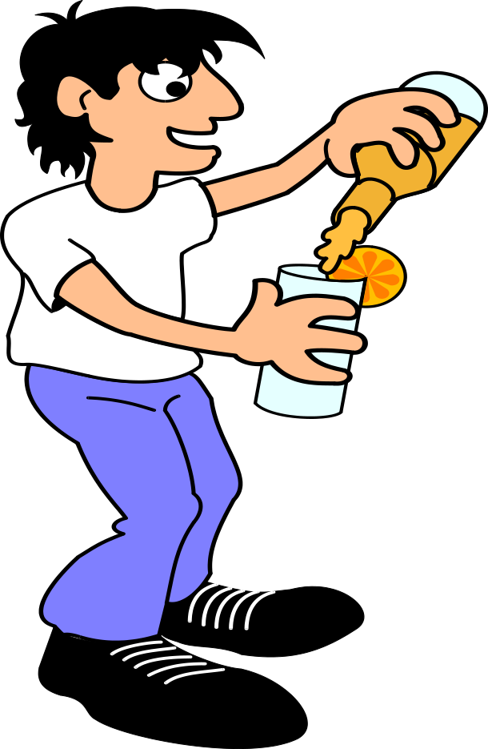

So my reasons for stopping drinking were that when I drank, I often drank too much. And then I couldn’t adequately control my own actions, either in terms of preventing stupid behavior or in terms of emitting appropriate behavior, and I couldn’t be sensitive enough to my environment. Once or twice, I’ve run into someone who would be offended at my declining a drink or who would make it a project to knock me off the wagon. However, that doesn’t seem to happen much anymore. (In fact, I used to have much more trouble, with-do-your-own-thing hippies who kept insisting that I do their own thing and have a few tokes on their joint.)

But I think there may be even more serious social problems resulting from alcohol. Looking around at various couples I’ve known, it seems to me that it’s really hard to maintain a decent relationship, and that alcohol makes it even harder. We seem much more likely to say something that will hurt the feelings of a loved one, after we have had a few drinks. Discretion is certainly the better part of valor in any marital relationship or anything even vaguely resembling a marital relationship. It seems like our tolerance for the other person’s weaknesses decreases, once we know that person well enough to love them. And our willingness to be especially considerate also decreases, as our willingness to point out their faults increases. And alcohol simply seems to make those problems worse.
It’s a great advantage not to drink among hard-drinking people. You can hold your tongue and, moreover, you can time any little irregularity of your own so that everybody else is so blind that they don’t see or care.—F. Scott Fitzgerald (1896–1940)

Here’s another variation on that same theme: we’ve all seen quite a few people who are intelligent and charming, when they’re sober; and may become even more charming and outgoing, after one drink. But they often have several which causes them to make complete asses of themselves. And that really is too bad. (Like if we’re at a party together and you’re smashed out of your gourd, please don’t throw your arm around my shoulder and tell me about the good old days, and how much you miss your deceased mother, and how she was the greatest mother in the world, and then wipe a tear from your eye, with my shirt sleeve. Go to the privacy of the bathroom instead, and get it on.)

I originally stopped drinking so as to get the most out of my interactions with my social and physical environment, and to contribute the most to those interactions, and to reduce my level of obnoxiousness, though I don’t want to suggest that alcohol was ever that big a part of my life. However, since then it has become more apparent that we also should be very concerned about the effects of alcohol on our health.
I’d hate to be a teetotaler. Imagine getting up in the morning and knowing that’s as good as you’re going to feel all day.—Dean Martin (1917–1995)
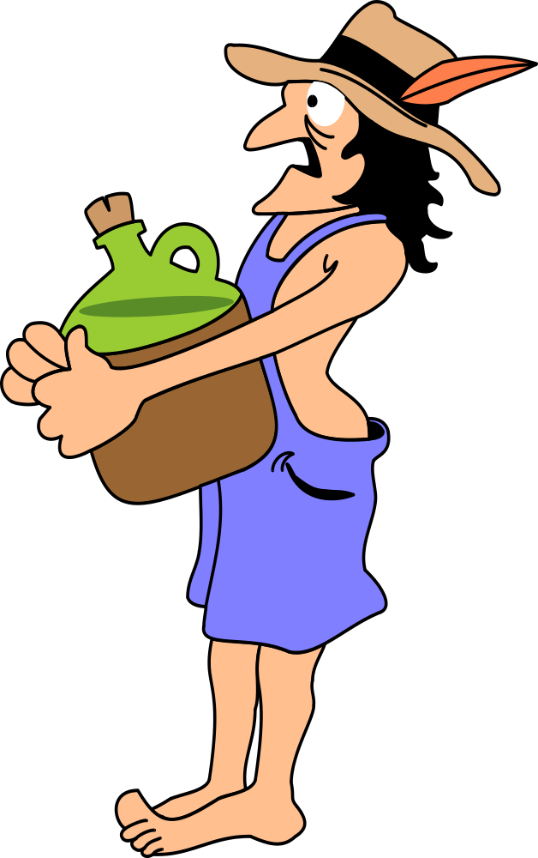

The Ten Evils of Alcohol

Here are some other problems with alcohol:
- Excess alcohol causes cirrhosis of the liver, of course.
- Alcohol inhibits the functioning of the brain by reducing the oxygen the red blood cells can carry to the brain cells.
- Alcohol inhibits your immune system thereby increasing your susceptibility to such diseases as pneumonia.
- Alcohol exacerbates arthritis pain by indirectly decreasing the oxygen to the cells in the arthritic area.
- Alcohol raises the level of triglycerides and other fats in the liver and blood, thereby contributing to atherosclerosis, gout, and diabetes.
- Pregnant women who are alcoholic lose one out of six of their babies and nearly half the survivors are at least a little mentally retarded.
- Alcohol is associated with cancer of the mouth, larynx, liver, and lungs, especially if the drinker is also a smoker.
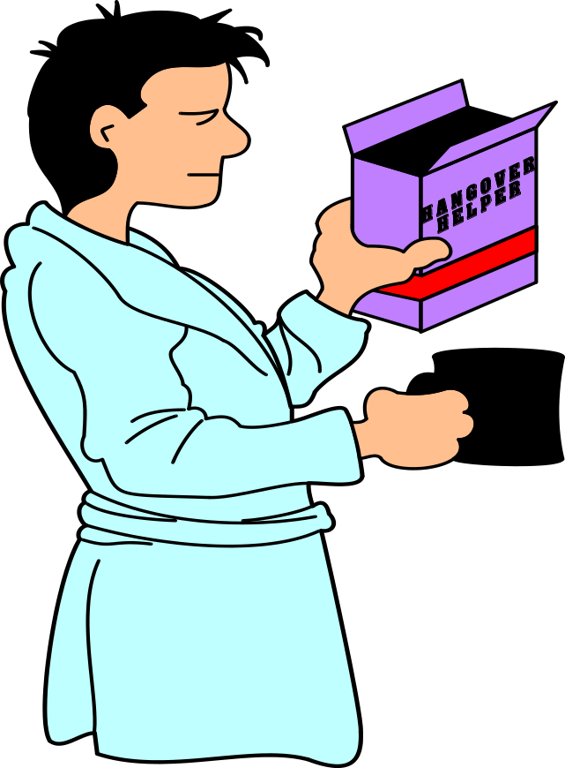
- Also, one-half of the automobile accident fatalities involve alcohol; that’s about 25,000 deaths a year more or less due to alcohol; so on the average, about one or two people die every day in every state in the US because of an alcohol-related traffic accident. And research with professional drivers indicates that alcohol impairs their judgment; although they have not consumed enough to be considered drunk, they would try to drive a bus through a space that was a foot too narrow.
- Alcohol generally makes you more accident prone, and not just in your car.
- Alcohol also increases the likelihood you will commit other forms of violence, for example, suicide or murder.

What to Do About Alcohol

Pritikin suggests that you not drink more than one four-ounce glass of wine a day. You can jog off the harmful effects that moderate amount of alcohol has on your triglyceride level. In fact, some data even suggest that such a moderate amount of wine might have some beneficial effects. However, two glasses of wine, and certainly hard liquor, is too much.

So above the moderate one glass of wine a day, alcohol does all sorts of bad things to us and those we interact with. On the other hand, it also serves at least two other useful functions. It decreases the aversiveness of many situations where we find ourselves. When we’re uptight, like before a party, we have a drink or two; and then we’re ready to face the ordeal. And serving and drinking alcohol is also a major part of the rituals involved in gracious living.

Well, I don’t have any good substitute to make it easier to face an aversive world. But I can say that during my 35 years on the wagon, my Puritanism hasn’t prevented me from living graciously and having a hell of a good time, most places I go. During that time I’ve logged in many hours in bars and night clubs and at parties with my hand wrapped around a glass of orange juice, or orange juice and soda water, or tonic and lime. And it works just as well as alcohol—better, because I’m now less likely to make an ass of myself or hurt someone’s feelings. Furthermore, I had no real trouble stopping my drinking of alcohol. I wasn’t addicted to it like I was to caffeine or nicotine. And there was simply no comparison between stopping my drinking and stopping my eating of sugar. Sugar was and still is 100 times harder for me to give up. But then I smoked, drank coffee, and ate sugar every day, whereas I had something to drink only two or three times a week.

So what I’m saying is that I’ve personally found it a good tradeoff to get rid of alcohol. It hasn’t been that hard, and the benefits far outweigh the losses.

Now if you think you also might want to follow the teetotaler path to health and happiness, then here are three routes to consider. Always try the simplest procedures first.
- Just announce that you’re going to stop drinking or drink no more than one glass of wine per day (assuming you’re also exercising off those triglycerides). And then stick to your commitment. That might do the trick, if you’re not into alcohol anymore than I was; otherwise bring out the heavier guns, probably one at a time until you’ve got what you need to help you stay clean.
- Make a public commitment. Write it down. Graph it. Add a penalty. Get the alcohol out of your house. If you need to, avoid those places where you keep falling off the wagon, at least for a while. In other words, don’t take your act on the road until you get it together.
- Finally, if people are saying you might be an alcoholic, though both you and I know you really aren’t, but you can’t manage to get it together, then get some outside help. And if you’re fortunate enough to have a behavior modifier in the vicinity, grab him or her for some advice.

Again, let me testify that although I had nothing resembling what anyone would call an alcohol problem, my life has been much better without demon rum. For example, I remember the good, old days, (35 years ago), when I used to have student-faculty parties, with a keg, or a few cases, though I didn’t drink even then. We had a great time. Many people would get drunk. A few would verge on belligerence. And most would pour themselves into their cars and swerve off into the night, with a much greater chance of being killed or killing someone. But the worst that ever happened was one asthmatic colleague passed out in his car at the side of the road in freezing weather without his medication. Fortunately a friendly cop, who had been a former student, happened by in time to save him.
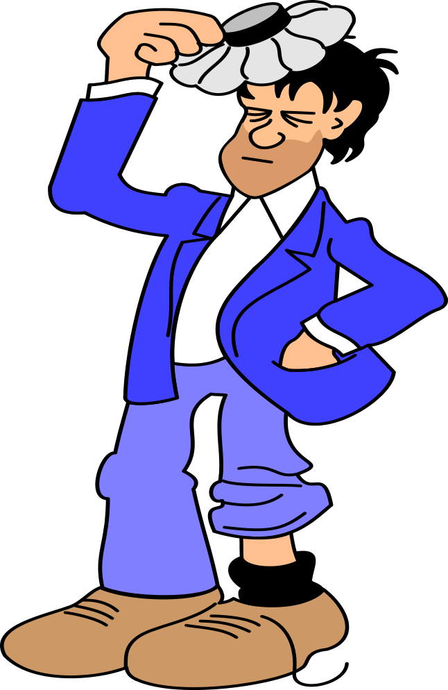

Those were great times. But I like the new times even better. Most of our parties these days, including the student-faculty parties, tend to center on potluck dinners. Often they’re Pritikin Potlucks, but often they’re not. When the students are mainly underclassmen, we sometimes end with a mild overkill on the potato-chip side of things. But they’re trying. And it’s B. Y. O. on the alcohol, though I do keep a gallon of inexpensive Southwestern Michigan wine in the fridge, as I don’t want to seem too inhospitable. But what I really push are Uncle Dickie’s famous Fruit Smoothies or Indiana apple cider, the Coors Beer of apple cider. So the rate of alcohol consumption is way down. We still have fun, and it feels much better. It’s a bit embarrassing for an old scalawag like me to admit that he enjoys good clean fun, but the truth must win out.
I’m only a beer teetotaller, not a champagne teetotaller.—George Bernard Shaw (1856–1950)

Nicotine—Smoking
U.S. researcher Joanna Fowler and her colleagues at the Brookhaven National Laboratory in Upton, New York, report that smoking reduces the enzyme monamine oxidase B in the brain, which leads to an increase in the amount of dopamine, a chemical that helps regulate mood, movement, and the reinforcement of behavior patterns. It is the first identification of a mechanism of cigarette addiction. High levels of dopamine are also found in other addictive drugs. February 21, 1996

Smoking is one of my favorite examples of the way sizable, probable reinforcers can get control over us to the detriment of those small but cumulatively significant outcomes. We sacrifice about eight years of our lives for our daily pack of cigarettes. But it may not matter that much, because smoking has made such physical wrecks of us by that time that we might as well be dead anyway.

Still, the process of becoming addicted to cigarettes is interesting. I remember when I first started smoking. It was the summer between my seventh and eighth grade years. Not a whole lot was happening in Converse, Indiana for twelve-year old boys back in 1948. So a few of us pooled our resources until we’d managed to amass 20 cents, which we then invested in a pack of Pall-Malls. (They were the only king-size cigarettes on the market at the time, and I was an advocate of cost-effective investments (more puffs per penny) even way back then.)

Now I’d be lying if I told you that my first puff was a real turn on. In fact, it took me five minutes to stop coughing. No, the natural consequences of smoking were aversive rather than reinforcing. But the social approval we young outlaws gave each other for our heroic deed was enough to keep us hanging tough. After our first shared cigarette, we buried the pack behind John Blake’s barn. You can imagine our dismay when we went to reclaim our treasure a few days later and found it full of ants. . . . ugh! Nineteen cents down the tube. But we regrouped. And we supported each other with our social approval for smoking and our scorn for not being man enough to take it. So by the time we were halfway through high-school, we had all become real nicotine junkies. We were hooked. But we were also cool. Men of the world. Fashion setters at Converse Jackson Township High School.

However, by the time we had hit our mid-twenties, fickle fashion had turned against us. Smoking was no longer in vogue. We were social outcasts. Our children lectured us on the evils of nicotine and tar. “Daddy, don’t smoke and die on us.” But it was too late. The monkey had a harness and saddle on our backs and was holding on for dear life.

Interesting: we get hooked because of the social approval, but it’s that lousy little nicotine rush that keeps us puffing right into our graves, even when the socials have switched on us. And that nicotine rush is such a cheap, threadbare, paltry little thing. At no point in the history of my degradation, did I ever say, “Oh, Camels, where’ve you been all my life. One hot puff from you is better than any root beer float I ever had, even a chocolate one.” No, each little puff was not that big a deal. But it was big enough and it was very, very probable. Suck and an instantaneous micro-relaxation, “ah.” Each puff produces a tiny little tranquilizing effect—not much, just big enough to enslave us. Puff, puff, puff. See Dick puff.
Smokers suck.—Uncle Dickie

The Nine Evils of Nicotine
- As everyone now knows, cigarette smoking increases the risk of cancer of the lung. Smoking causes 90% of lung cancers among men and 79% among women. If you smoke two or more packs of cigarettes a day your chances are 12 to 25 times greater of dying of lung cancer than if you don’t smoke. But it turns out that lung cancer is just the tip of the iceberg. Are you ready for the rest of the list?
- Smoking also increases the risk of cancer of the larynx, oral cavity, esophagus, bladder, kidney, and pancreas. Smoking accounts for 30% of all cancer deaths. Why? There’s a gene that prevents growth of cancer cells; and cigarette smoke screws up that gene, with the result that the cancer cells go crazy in smokers.
- Smoking causes you to inhale large amounts of carbon monoxide, and cigarette filters even increase the amount of carbon monoxide up to 28%. And the carbon monoxide prevents your red blood cells from carrying the oxygen your body needs. And if you’re also doing a lot of fat, then the whole process combines to start filling up your arteries with plaque even faster than if you were just into the grease without the smokes. So you’re more likely to have heart disease, stroke, hypertension, angina—atherosclerosis city. You’re probably 5 to 10 times more likely to die of heart disease if you smoke.
- Smoking speeds up aging. For instance, osteoporosis (loss of bone). So you too can lie around with a broken hip that never mends. As another instance it increases the aging of your skin, its wrinkling, crows feet, and loss of elasticity.
- Smoking can increase your problems with emphysema and other bronchial diseases.
- Smoking can cut down your field of vision by at least 36%, so that it’s like driving your car with side blinders on.
- Smoking can also cut down on your hearing and your taste. But maybe that’s all right, ‘cause then you can just concentrate on that cigarette without being bothered by all those distracting audiovisual stimuli, like the song of a bird off in the distance. Just puff away.
- And the latest word is that smoking also takes calcium out of your bones.
- Smokers more frequently give birth to premature or underweight babies.

In summary, cigarettes cause 400,000 deaths per year in the United States. Cigarettes kill 20 times more Americans than all other addictive drugs combined. Cigarettes are the most preventable cause of death in America. If we’re going to do a war on drugs, guess where we should start.

Well that’s some bad news. Now here’s some good news: If you stop smoking, you can reverse many of these harmful effects. The less you’ve smoked and the sooner you stop, the faster you’ll recover. And in many respects you can get back to almost normal after you’ve been off the weed for about 10 years.

Smoking is the most preventable cause of death in our society. In fact, nearly one in five deaths in the United States results from the use of tobacco. (To repeat:) Based on research from the American Cancer Society, each year smoking claims more than 400,000 lives in the US. Almost half of all smokers between the ages of 35 and 69 die prematurely. Smokers could be losing an average of 20 to 25 years of their life.

Ninety percent of new smokers are children and teenagers. The new smokers replace the smoker who quit or died prematurely from a smoking related disease. As the numbers of smokers increase, the number of deaths from lung cancer increases (see above table). Nonsmokers exposed to smoke are also at an increased risk for lung cancer. A nonsmoker married to a smoker has a 30% greater risk of developing lung cancer than the spouse of a nonsmoker.

Information from the American Cancer Society http://www.cancer.org/tobacco/index.html

Over 40 million people in the United States have made the decision sometime in their lives to quit smoking. According to the U.S. Surgeon General, "Smoking cessation (stopping smoking) represents the single most important step that smokers can take to enhance the length and quality of their lives."

Smoking Readers: Please check this one out:

http://www.cancer.org/tobacco/index.html

Of course, all this is irrelevant to smoking students at places like Western Michigan University, where they are required to do their smoking outside of the classroom buildings in freezing winter weather. They all die of pneumonia before the direct effects of nicotine have a chance to trash their bodies and the bodies of their unborn infants.

How to Quit Smoking

Quitting smoking is one of the hardest things most people ever try to do. Maybe even harder than dieting. I managed to quit over 35 years ago, but I can’t tell you how. I didn’t use behavior mod. Instead, everybody got on my case. So I stopped smoking just to get them off my case. Of course, I also knew about the big cancer scare by that time, so I was up for it.

Actually I can tell you what I did, but I don’t know how crucial it was to my stopping. I switched over to those little cigarette-cigar jobs that come in a package like cigarettes. They were terrible. I smoked those for a few days, until I found myself starting to inhale them. And at that point I quit everything.

But here is the rest of the good news. Richard Foxx and Richard Brown did some excellent research on how to quit smoking. And they developed a very good technique. Their procedure is to be done with the help of a professional behavior modifier. But it might be worth trying by yourself, or you might even form a special group to do it with you, at least if you don’t have a friendly neighborhood behavior modifier at your disposal.

Here’s how it works: If you’re much of a smoker, then you’re probably a nicotine addict, and you’ll go through the physical discomforts of withdrawal, if you try to stop cold-turkey. So, Foxx and Brown recommend that you cut back gradually. And they have an especially clever way of cutting back. Each week, you switch to a brand of cigarettes with 30% less nicotine, and quit smoking all together in the fourth week. So its 30% less, then 60%, then 90% less, and then none. But the nice thing about this way of cutting back is that there’s no limit to the number of cigarettes you can smoke, if you don’t revert to a stronger brand, and if you go for a milder brand each week. (Throw those harsher ones right out the window; put Satan behind you.)

So you’ve got a nice, clear-cut rule that’s easy to monitor: “Smoke only the brand of the week, but as many of those as you like.”

However, it turns out that simply going for milder and milder cigarettes doesn’t do it by itself. You need to do a little graphing also. You need to plot the amount of tar you’ve consumed each day. You do this by counting the number of cigarettes you’ve smoked that day and multiplying that number times the amount of tar in each cigarette.

It turns out that when you do this graphing you’ll see that your nicotine consumption decreases each week, although you might increase the number of cigarettes you’re smoking. For instance, suppose you switched from a daily pack of Winston filter Kings to Carltons; you’d have to smoke 19 packs of Carltons to get as much nicotine as you get from that one pack of Winston Filter Kings. In other words, you don’t increase the number of cigarettes enough to compensate for the decreased amount of tar in the cigarettes. So, the result is you gradually wean yourself from the nicotine over a three week period, and then it’s fairly easy for most people to stop smoking altogether.

The research on this procedure shows that each component is very important to have the best chance of cutting down on your smoking or stopping altogether: you need to cut down on the nicotine by 30% each week, and you need to plot your nicotine consumption on a graph each day. Some more recent work also suggests it might be a really good idea to show your graph to someone every week, maybe for as long as a year. I suspect that would help you stay clean longer.

The Evils of Caffeine
Withdrawal symptoms

If you drink more than six cups of coffee a day, you’re probably a coffee addict. For instance, you’ll probably show withdrawal symptoms, if you suddenly stop drinking coffee. You may start having headaches, get nervous and irritable, be depressed, or suffer constipation or nausea. And those symptoms may last for a week.
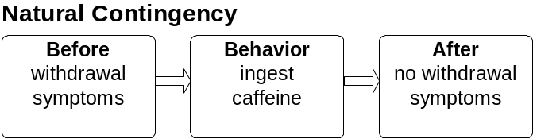
Habituation

Furthermore, you’ve probably habituated to the drug so that you’ve had to gradually increase your daily dosage to get a sufficiently reinforcing effect.
Caffeinism

If you drink as many as eight cups of coffee a day, you’re a prime candidate for caffeinism. The relevant symptoms are nervousness, irritability, tremulousness, muscle tension, poor sleep, enuresis (frequent urination), loose stools, gastrointestinal upsets, and heart palpitations. And three Cokes a day is enough to produce caffeinism in a 60 pound child. And the kid can get even more caffeine from his chocolate bars. So caffeinism is a serious problem among children as well as adults.

Other Physiological Effects

Caffeine produces high free-fatty acid levels in the blood, high blood-sugar levels in diabetics, increased gastric acid secretions, and high blood pressure.
And more

Now researchers have not nailed down all the harmful effects of caffeine, but here are some problems caffeine may be involved with: myocardial infarction (death of part of the main muscle tissue of the heart due to oxygen starvation), a 40% increase in the chance of developing peptic ulcers, birth defects (caffeine the pregnant mother consumes can enter the fetus), or damage the chromosomal structure, fibrosystic breast disease (benign lumps), a very high risk (15 out of 16) of spontaneous abortion, stillbirth, or premature birth if the mother drinks more than five cups of coffee a day.

You probably shouldn’t assume that you’re safe if you keep it to just four cups of coffee per day, for instance, because there isn’t really any clear cutoff point; the less you drink, the better off you’ll be. In addition, individuals differ greatly in their susceptibility to drug effects. One of the factors is body weight, but that doesn’t account for all the differences between individuals. So it seems to me like the potential risks of unnecessarily screwing around with any drug far outweigh their benefits; and that sure includes coffee.

How to Quit Drinking Coffee

At the suggestion of a friend, I quit coffee by using a method pretty much like the one I recommended for quitting cigarettes. First I switched from regular coffee to instant coffee. Then I made up a special mix: 1/3 instant decaffeinated coffee and 2/3 instant coffee with caffeine. Then every week I cut the caffeinated coffee with a little more decaf, until before long I was caffeine free and painlessly to boot, no withdrawal symptoms. Also no graphing, or behavioral contracts. It was easy, and I started with a pot-a-day habit. But if I’d had trouble, I’d have plotted the amount of caffeine I consumed each day, and maybe set some goals for reduction, and added whatever else I needed in terms of behavioral contracts and penalties. And if I were doing tea, Cokes, and chocolate, I’d have taken them into consideration also.

But it turns out I wasn’t home-free, just because I’d gotten down to decaf. My dental hygienist told me that decaf would stain my teeth really badly, and the last thing my teeth needed was a coating of plaque, which the stain would facilitate. And since then Pritikin has also expressed some concern over the slightly toxic substances in decaffeinated coffee. And he’s also a little concerned about most herb teas. So I eventually said “to hell with it” and switched to water. You know what? Plain water has worked just fine!

I’ve got a little theory about why water works so well. There’s a phenomenon known as psychogenic pollydipsia which means that a person drinks an excessive amount of fluid for psychological reasons. Now those reasons aren’t really clear, but that drinking seems to be something we do when we’re engaged in certain sorts of activities, like reading, or typing, or watching the tube. It’s not really that we’re thirsty, but we just get up periodically and go for a drink of water. I even got to the point were I kept a quart jar of water sitting on my desk while I was writing.
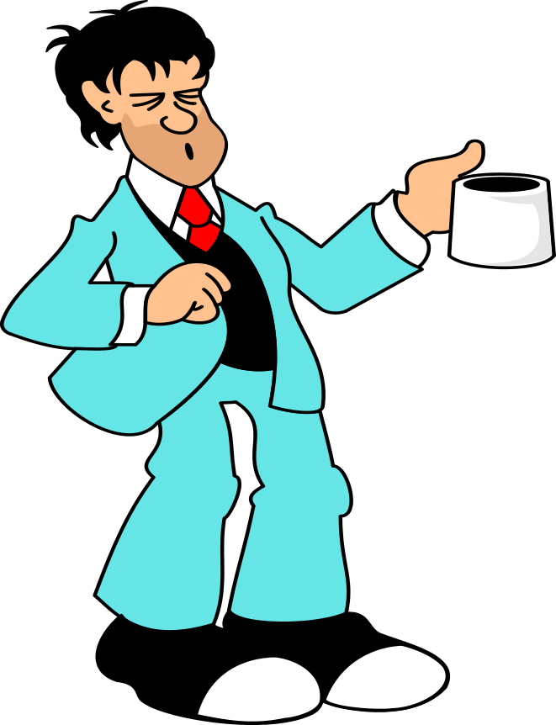

I think we often consume food in much the same way—like the bowl of popcorn we munch, while we’re watching TV, right after supper. We’re not hungry, but it’s reinforcing to eat. However, if we’re engaged in some physically strenuous activity, I think we tend to partake of much less of that psychogenic drinking and eating, at that time.

Anyway, a lot of our drinking may be psychogenic; the main reinforcer may be the water itself; however, we often drink our fluids in the form of Cokes, or coffee, or beer, or milk; and then we get into a real problem. And those foreign substances in our water, the caffeine, or the alcohol, or the milk, are added reinforcers, often addictive ones. But if we eliminate them, gradually, we may find that just plain water will do the trick really well.

That also happened with a friend of mine when his doctor told him to stop drinking a six-pack every night. Instead he just settled down in front of the tube each evening with a quart of water, and gradually he started approaching a more normal weight and a healthier body.

So I don’t think you should have too much trouble shaking the coffee habit; just take your time, and be sure to make a little progress each week; you’ll get there.

The Evils of Marijuana

In spite of my interest in jazz, rock and roll, the long hair I used to have and the beard I still have, I’ve never smoked marijuana. A living anomaly? Perhaps because I’m a child of the ‘50s when the general culture was a little more nervous about the effects of dope. “If it wasn’t bad for you itself, at least it might lead to a heavy heroin habit.” I didn’t have any really good reason not to smoke dope. So I’d say I simply wanted not smoking dope to be the one piece of advice my mother gave me that I actually followed. And then later, as a joke, I used to say I thought marijuana smoking might lead to tobacco smoking and tobacco smoking might lead to cancer.

I suppose I was also offended by the hipper-than-thou attitude of the essentially square university faculty passing around their reefer at parties. And I was also turned off by the sanctimonious attitude of the health-food hippies as they filled their bodies with the unknown effects of marijuana smoke between bites of tofu.

And I think that’s still close to the bottom line: We don’t really know. It’s not enough to say, “I know people who’ve smoked dope at least once a week for over four years now, and nothing’s wrong with them”. Right on, straight ahead, brother. Tell me about it when you’ve known one million people who’ve done dope every day for 40 years and you’ve contrasted them with a million comparable people who haven’t, when you’ve done detailed medical histories and exams on both groups, and I won’t even insist on data on their offspring. Tell me about it when you’ve got the kind of data it took to assess the evils of tobacco, salt, fat, and white bread. We just don’t have those data yet.

Here’s the way they put it in a popularized book from Harvard Medical School. If you smoke marijuana you should know you’re taking part in an unplanned experiment the population of our country is carrying out on itself. You may be part of the statistics medical researchers will use 40 years from now in their evaluation of the long-terms effects of dope.

But I’m more than a little suspicious up front. I’m a little reluctant to drink, eat, smoke, or breathe anything our ancestors did not drink, eat, smoke or breath during the time of our evolution, during the time when our bodies were evolving to cope with our environment.

It seems to me we’re running a hell of a risk, whenever we consume anything our bodies have not evolved to deal with. The further we get away from the natural conditions of our evolution, the bigger the risk. And there’s no evidence that prehistoric people sat around in caves sucking on hookahs.

Now don’t get me wrong, I love to defy authority. I love to flaunt other people’s uptight rules. I love to live just on the margins of the law. I love to rebel against society’s arbitrary mores. But not if it means I’m exposing my body, the only one I’ve got, to an unknown, but potentially heavy, health hazard. So I just sit there thumbing through High Times, while everyone else gets stoned out of their gourds.

Well, here’s one little dope evil to consider, if you’re not too stoned to remember it: According to the University of California, Berkeley’s Wellness Encyclopedia (page 512), marijuana can screw up judgment, perception, attention, and performance so much that it “can certainly endanger human life,” especially when the stoned is operating some heavy hardware, like a car. And, here’s the really weird part; are you ready for this? Once that marijuana THC (tetrahyrocannabinol) gets from your bloodstream into your brain and fatty tissue, which it’s quick to do, it may linger there for days and even weeks and make a return visit when you’re least expecting, like when you’re driving a car, and especially after you’ve had a couple beers. And then it’s:

Splat! One less doper.

But, Geez, Saint Pete, I only had one joint.

And Saint Peter says, “Awwwwwwwww, tsk, tsk, didn’t you know that the Procrastination book was heaven sent?”
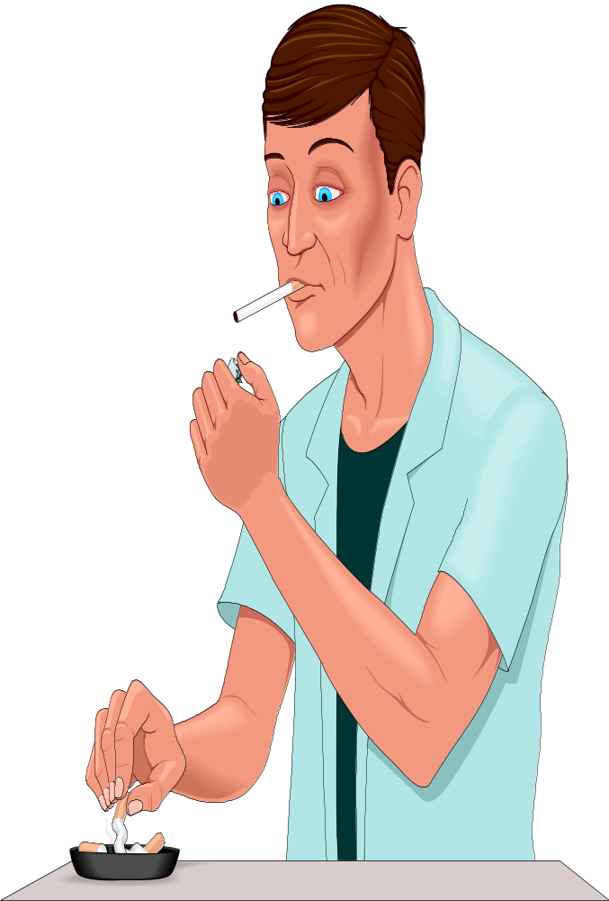

Case Study Doing Battle with the Nicotine Devil #1

Jason Otto, MA Student, 1998

Analysis of the Problem

I began smoking when I was a senior in high school, prompted by the typical social reinforcement (approval) from peers who smoked. Of course, the smoking was maintained over time, in part, due to the nicotine addiction. My smoking increased gradually as other contingencies of reinforcement took control over me (I’ll explain later).

Of course, smoking is a problem because it trashes your health in many a way and shortens your life, from day to day.

I analyzed the ineffective natural contingency first. The behavior was not controlled by the natural contingency that described the infinitesimal decrease in my health.
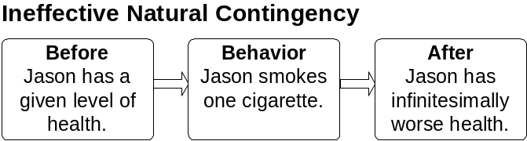

I was well aware of the effective natural contingencies maintaining the smoking behavior as well. The primary effective contingency that maintained the response was escape from the aversiveness of nicotine withdrawal. This contingency may be effective for the first response of smoking after a sufficient deprivation of nicotine.
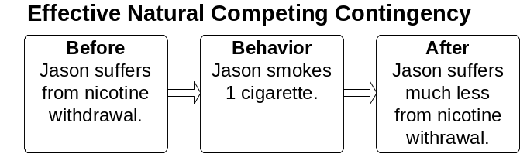

On the other hand, the calming effect of the nicotine tranquilizer most likely maintained my smoking by helping me reduce my aversive uptightness, another escape contingency.
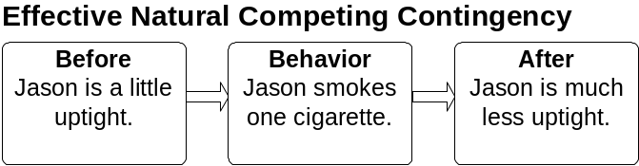

The Objective

I planned to decrease smoking a significant amount, but I expected that the behavior would decrease gradually not immediately.

Design of the Intervention

I added an analog penalty contingency to address the ineffective natural contingency. Also, because of the tranquilizing reinforcement of the nicotine, I would reduce the nicotine content of the cigarettes by 30% each week (roughly). This would reduce the reinforcement, or value of the reinforcer following each response. This also addressed the nicotine withdrawal effects.
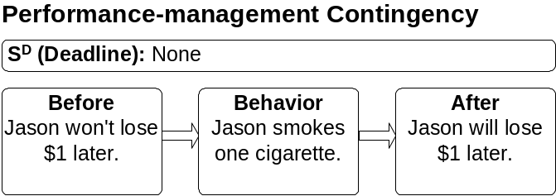

Implementation

I announced in front of my classmates that I would pay $1 for each cigarette that I smoked. In addition, I would begin the intervention with a decrease in the nicotine content of each cigarette. And I asked Jon to act as my performance manager by taking my money for cigarettes smoked.

Evaluation

I immediately succeeded in going from 59 cigarettes smoked in the week of baseline to 18 in each of the immediately following weeks.
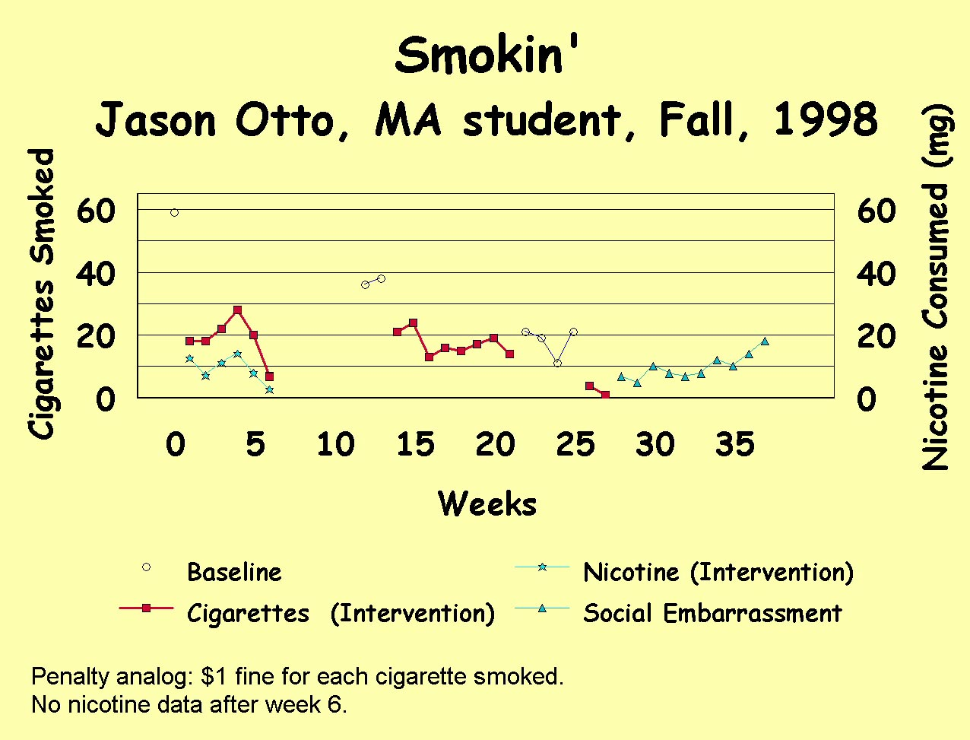

Recycling

I recycled by analyzing the performance- management contingency that allowed no room for error. I decided to allow two cigarettes a day. The rationale was that I thought the intervention was successful, but the penalty was continuing to be high. I also attributed my maintained level of cigarettes smoked to an increase in the withdrawal, or the increase in the effectiveness of the competing natural escape contingency. Therefore, wasting money during the natural process of withdrawal reduction caused me to rationalize a little forgiveness.

I changed the original performance-management contingency midway in the fourth week: I started allowing myself to smoke two cigarettes each day, before I had to pay a penalty.
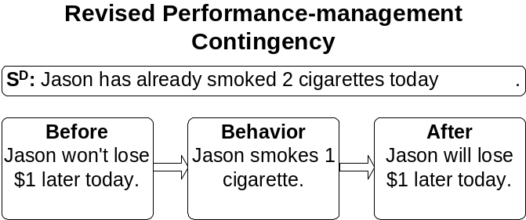

About the same time I changed the performance-management contingency, I had to admit that my performance manager and I were not reliably implementing the contract. From then on, I had daily prompts for a confession of smokes smoked. The response rate decreased in the sixth week.

Also, in the fifth, sixth, and seventh weeks, I randomly smoked cigarettes of .4 mg of nicotine and .7 mg of nicotine. The reason for the random failure to keep on the lower nicotine level is the availability of the .7 mg cigarettes. Amy, my girlfriend, continued to buy that level while I rarely bought at all (I did buy the .4 mg level when I bought, however), leaving me to bum them when the sight of the cigarette turned me on.

The first seven weeks are all that was in my original class project. I’ll discuss the remaining data in the follow-up section.

Discussion

My take from this project is that it’s very hard to manage my own behavior. I also found that money is a hard incentive for me to assess. At times I can spend money as though the outcome was small but cumulative. Also, a fine line divides where the money is effective, but so effective as to suppress my honest admission to the smoking and the paying of my penalty.

Follow-up

After the seven weeks of the summer course, I stopped taking data for five weeks. Then on weeks 12 and 13, I collected baseline data again. My frequency of cigarette smoking had gone way up, but not nearly as high as during the first baseline. From weeks, 14 through 21, I went back to the analog $1-penalty contingency; and my frequency dropped back down to usually less than 20 per week. And during the four-week Christmas-break baseline, it stayed around 20 per week.

From the beginning of winter ‘99, I changed from the loss of $1 per cigarette smoked to the loss of the opportunity to get back all the penalties I had paid in the Fall. I had accumulated $60 worth of penalties during the Fall (Sarah had it). In other words, I implemented an analog to punishment by prevention of a reinforcer.
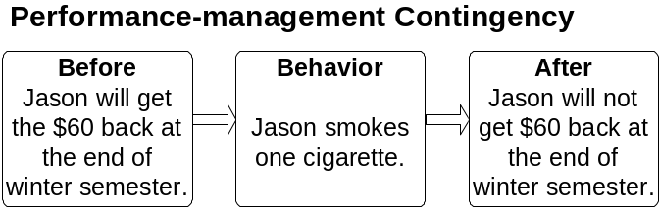

The $60 contingency really brought down my frequency of smoking for a few days, but I blew it in the first week so I kept the contingency going for only a week.

In retrospect, I couldn’t expect that contingency to have a long-term effect, because I could only contact it once; after smoking one cigarette, I had no more $60 accumulations to lose. But it was interesting to try.

I tried to keep the smoking down after I blew the $60, and it took a couple weeks before I solidified the next contingency. I realized I would have to tell everyone I had screwed up, and the following social contingency naturally flowed from that realization.

Sarah, my performance-manager and I agreed that I will begin goal setting as part of the social contingency. Last week I slipped up to 18, and I stated that was not good at all. So now I will publicly state a goal (e.g., “next week it will be below 18”) and then tell my BATS colleagues how I did at the next weekly meeting. As for the nicotine intake, I’ve stayed with Camel Lights, which are .7 mg.

Anecdotally, I’ve bought considerably fewer cigarettes myself. In other words, having these contingencies on smoking doesn’t keep me from smoking altogether (Amy has always got some), but buying looks like it’s being punished.

Case Study. Doing Battle with the Nicotine Devil #2
Ann M. McGarth, Ph.D. Student, 1997

Analysis

I’ve been smoking for many years and tried to quit several times, once succeeding for two years before picking up the nasty habit again. So I knew this would be a tough project. But it could affect three of the 4 H’s: Healthy because I’d be a more physically healthy person. Happy because I would live a higher quality of life. Harmless because I would no longer expose others to my harmful secondhand smoke.

Design and Implementation

For each cigarette I smoked, I had to pay my performance manager, my friend Brian, $3 on Friday at morning coffee. I chose Brian as my performance manager because I thought he would reliably check up on me. He turned out to be a real tough guy who looked forward to his money and to telling all of our friends how much I’d paid him that week.

Evaluation

The three days of baseline represent my past three years fairly well. The performance-management contingency had a major effect on my smoking.
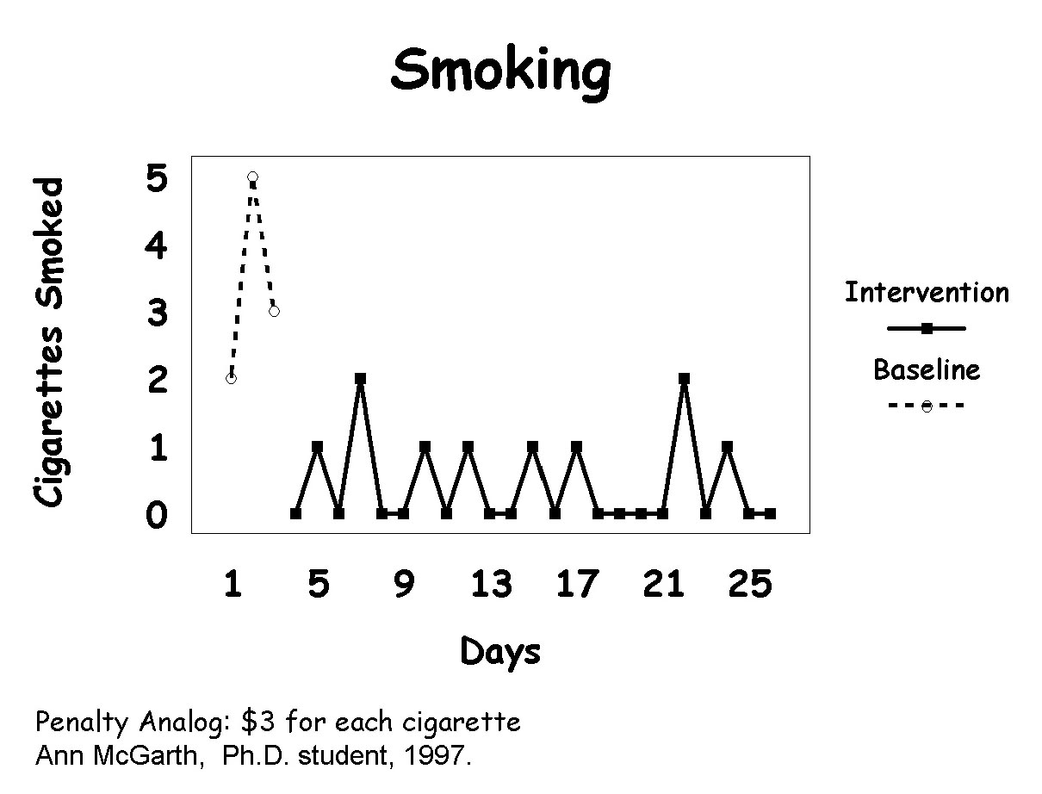

I still have the contract running and plan to do so for some time. Brian says he’ll hang in with me until I go on my internship, although he admits he’s sad I’m not paying him quite as much money as I was in the past.

tee·to·tal·er—One who abstains completely from alcoholic beverages. The American Heritage Dictionary of the English Language, Third Edition, 1992, Houghton Mifflin Company.
Dr. Ronald Hutchinson, an experimental behavior analyst, and his colleagues have shown that nicotine acts as a mild tranquilizer for squirrel monkeys. Here’s a little more info from my colleague, behavioral pharmocologist, Dr. Alan Poling: The effects of nicotine are complex, both neuropharmacologically and behaviorally. The primary action of the drug is on acetylcholine receptors. Initially, it stimulates them, but later, it blocks them. The former action can lead to a release of epinephrine (adrenaline) “downstream.” You’re right concerning Ron Hutchinson’s findings. Other work (with humans) suggests that the drug can be used to modulate arousal - kicking it up when people are tired, for example, and reducing it when they’re stressed. Drugs, like gods, work in mysterious ways.
Some of the information in this section comes from The Encarta® 99 Desk Encyclopedia , 1998 Microsoft Corporation, New World Timeline, 1998, Helicon Publishing Ltd., and New World Almanac, 1998, Helicon Publishing Ltd.
Everyone cheats once in a while. The important thing is to blow the whistle on yourself, if your cheating is trashing your self-management project. You blow the whistle, and change things so it’s harder for you to cheat in the future. The big sin is not cheating; it’s failing to blow the whistle.
Dope, drugs, alcohol, nicotine, caffeine, whatever; it’s all the same old crap, just vehicles for transferring your hard-earned money to rich fat cats and trashing your body at the same time.

